|  |  |
| --- | --- |
| **Auteur(s):** |  |
| Sander Jochems  Bram Swinkels |  |

|  |
| --- |
|  |
| Configuratieoverzicht |
| *Voor de Online Stemmer* |

[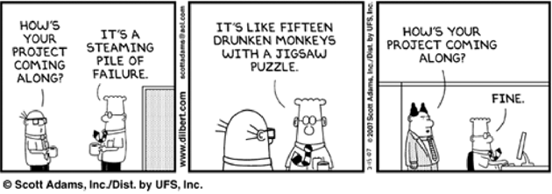](http://www.google.nl/url?sa=i&rct=j&q=&esrc=s&source=images&cd=&cad=rja&uact=8&ved=0ahUKEwj46a3X26LPAhXBoBQKHQITCSgQjRwIBw&url=http://arunkottolli.blogspot.com/2012_09_01_archive.html&bvm=bv.133387755,d.ZGg&psig=AFQjCNEuMwRJzUvAm2kVnQYQ-u33UUdg2A&ust=1474624737562039)

**Inhoud**

1. Te gebruiken hardware 4

2. Te gebruiken software 5

# Te gebruiken hardware

|  |  |
| --- | --- |
| Apparaat | Vereisten |
| Laptop Sander | 2,5 GHz Processor (I5 7200U)  256 GB SSD & 1000 GB HDD schijfruimte  16 GB Ram  Nvidia GeForce 950M  2x USB 3.0 Type A  1x USB 3.1 Type C  1x USB 2.0 Type A  1x HDMI 2.0  1x VGA  1x Ethernet  1x 3.5 mm Jacket |
| Laptop Bram | 2,5 GHz Processor (I5 7300HQ)  256 GB SSD & 1000 GB HDD schijfruimte  8 GB Ram  Nvidia GeForce 1050  3x USB 3.0 Type A  1x USB 3.1 Type C  1x HDMI 2.0  1x Ethernet  1x 3.5 mm Jacket |

# Te gebruiken software

|  |  |  |
| --- | --- | --- |
| Software | Versie | Opmerkingen |
| Windows | 10 | User: Sander |
| Visual Studio | 2017 | Regelnummering aan  Crystal Reports plugin  MySQL Data Reference |
| Visual Studio Code | 1.20.1 | Dark Theme |
| XAMPP | 3.2.2 | Apache: 2.4  MySQL: 10.1.26-MariaDB |
| GitHub Desktop | 10.0.14 |  |
| Office 365 Pro | 2016 |  |